QMS202 SPSS Project

The prediction of the US dollar on changes of commodity prices.

July 26th, 2019

Business Statistics II

CQMS 202

Britney Lamothe 500882305

Don Kim 500486770

Leandra Lai 500765774

Ka Chun Lau 500715415

**Table of Contents**

Background

Research Objectives

Data Collection

Data Analysis using SPSS

Conclusion and interpretation

Appendix A. Data Set

Bibliography

**Background**

Generally speaking, there is always an inverse relationship between the US dollar and most highly invested in commodity prices. History has shown that the prices of commodities in the US have shown a tendency to drop while the US dollar value strengthens against other major currencies. On the contrary, based on historical data, when the value of precious commodities goes up, the price of the US dollar will drop against other major currencies. The examples above are a reflection of the fact that the US dollar is the benchmark pricing mechanism for most commodities worldwide, this is because the US dollar is consistently the most stable foreign conversion instrument. Hence, as mentioned, the US dollar and the commodity prices show an inverse relationship from one to the other. A lot of countries hold US dollars as reserve assets because of this valued consistency. In many situations, the US dollar is also a common exchange mechanism. It will cost more to people using US currency to purchase goods and materials if the value of the US dollar drops. Conversely, the US dollar has such a profound impact on international markets is due to the fact that commodities are not limited to only the US nation. The US dollar, as mentioned, is a benchmark way of scaling highly valuable stocks prices and therefore impacts the international market everytime it changes. This is why when the US dollar drops foreign buying power increases.

For the purpose of this report, our group will use multiple linear regression to analyze a real life situation regarding the inverse relationship among the US dollar, gold and oil prices. We chose these two commodities because they are two of the most recognized and valued international commodities on the market. Multiple linear regression will help us to predict the the US dollar value based off of the changes in the commodity values.

**Research Objectives**

We are conducting our analysis from an investor's perspective. This research is an attempt to further our understanding of making good judgements on equitable investments. By analysing the US dollars relation to two of the largest US commodities - Gold and Oil, we are able to see how the US dollars USDX appraised value has an impact on the return of large stocks.

The values of both commodities can vary from time to time. This is, as research has shown, because of the common rule that: When the value of the US dollar increases, the price of the mentioned commodities will most commonly drop for buyers using US currency. While the price of the commodity moves higher, there will likely be fewer buyers as demand declines. Consequently, if the value of the US dollar goes down, commodity prices will tend to rise in the market as it becomes ‘cheaper’ in other currencies. High commodity prices can be caused by high demand in the market, insufficient supply, or the drop of the US dollar’s value. Considering most oil contractors around the world are traded in dollars, therefore, commodity exporting countries will need to buy/use the US dollar. In the case of the US dollar declines, the commodity revenue will decline at the same time. However, the cost goes up as the drop in the US dollar’s value drives to cut down oil production, as an example and this causes the supply of oil to decrease, leading oil prices to increase. We would like to prove that the stock value of gold and oil has a direct relationship with the US dollar, which proves that the best time to invest in gold and oil is when the US dollar is at a low. We would like to also test if there is a relationship between the stock price of oil and gold and US currency.

**Data Collection**

Data is collected from investing.com. The range of data is dated from Aug 2010 to July 2019 and the data is listed in Appendix A. The US dollar index, gold commodity futures and crude oil commodity futures are used to conduct an analysis and the unit of prices are in US dollars. The average price of each month reflects each value. The US dollar index measures the US dollar value compared to other major currencies. This is a good reference as it provides accurate data for our analysis. Futures are widely traded among brokers because it is more efficient and liquidable than ETF (Exchange Traded Fund). [Why Trade Futures] Therefore, we used future data sets for our analysis. The number of samples are 107. The number of independent variables are 2. This data does not consider the inflation rate.

**Data Analysis using SPSS**

The 4 assumptions are required so as to use a multiple linear regression.

* Linearity
* Independence of error
* Equal variance
* Normality

1. Test the linearity assumption

A scatterplot of USDX against gold and oil, in Figure 1 and 2, shows a straight line. It verifies that there are linear relationship on dependent against independent variables. An assumption of linearity is not violated.

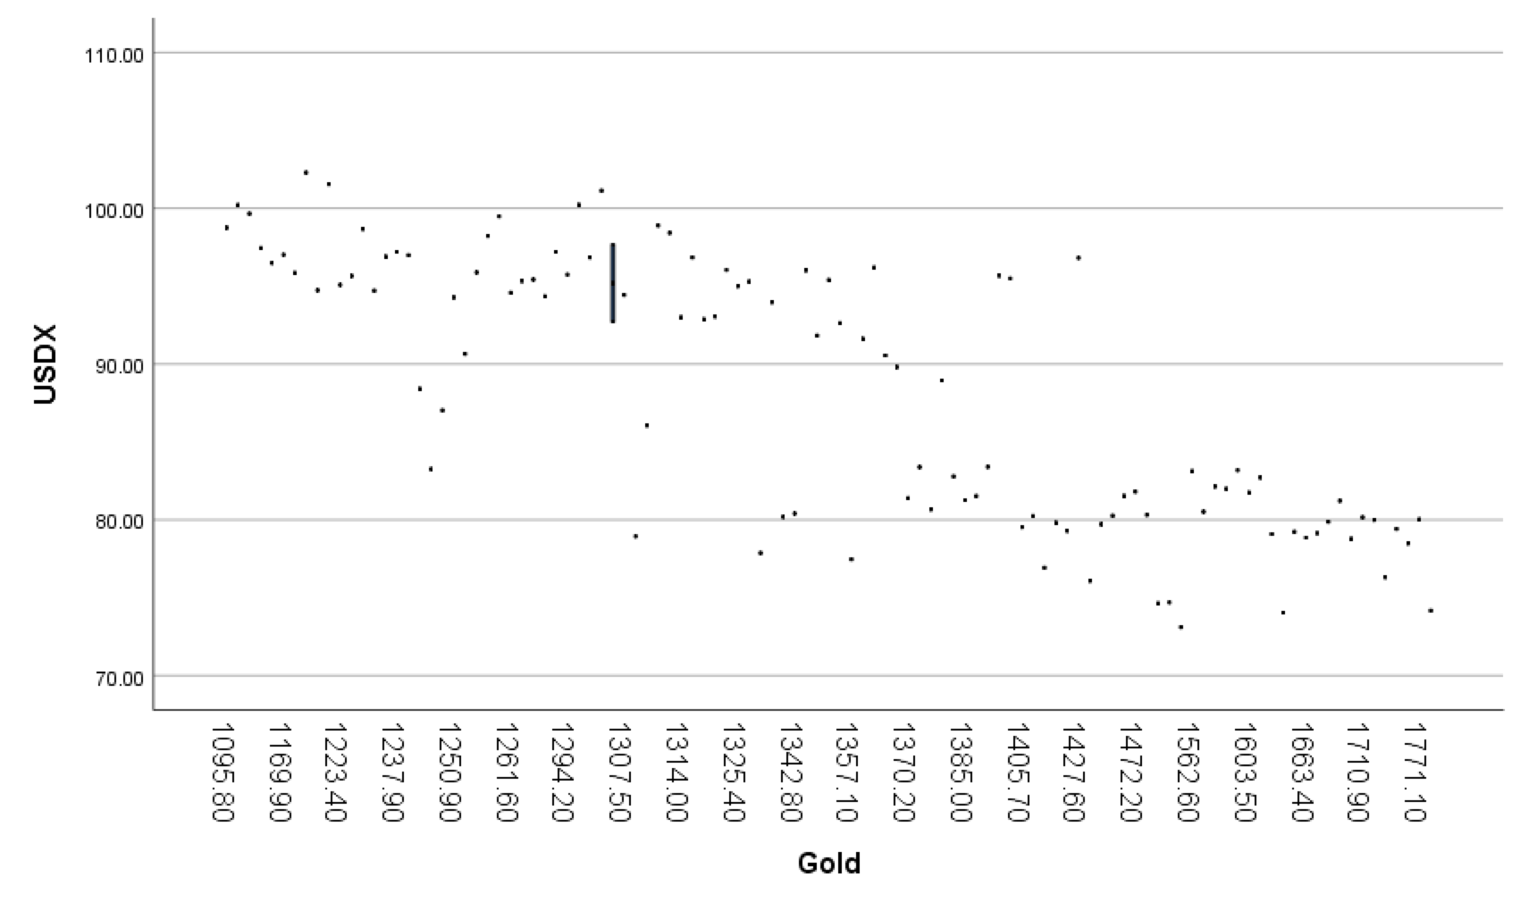

Figure 1 A scatterplot of Y (USDX) against X1 (Gold) vs Gold

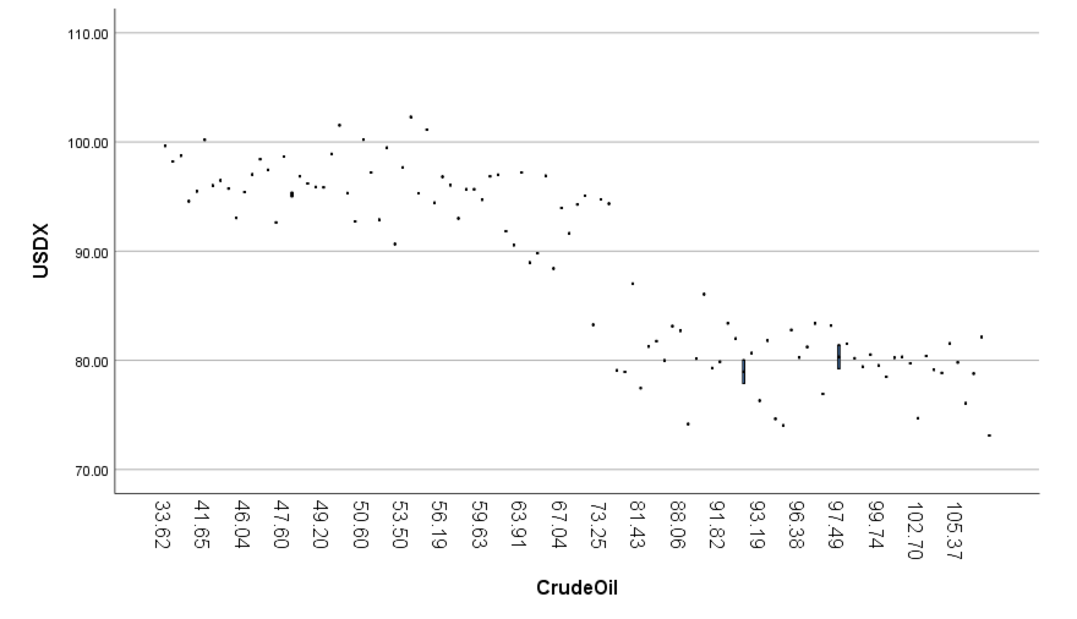

Figure 2 A scatterplot Y (USDX) against X2 (Crudeoil)

1. Test of independence of errors assumption

We are looking for a curvature pattern on the scatterplot of residual against gold and crude oil. All the variables are distributed through a zero horizontal line of residuals and there is no clear curvature pattern on both scatterplots, Figure 3 and 4. An assumption of independence error is not violated.

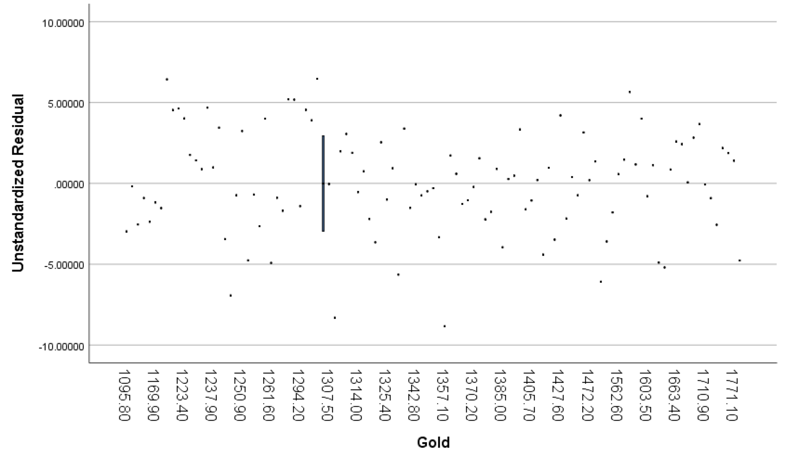

Figure 3 scatterplot of residuals against gold X1

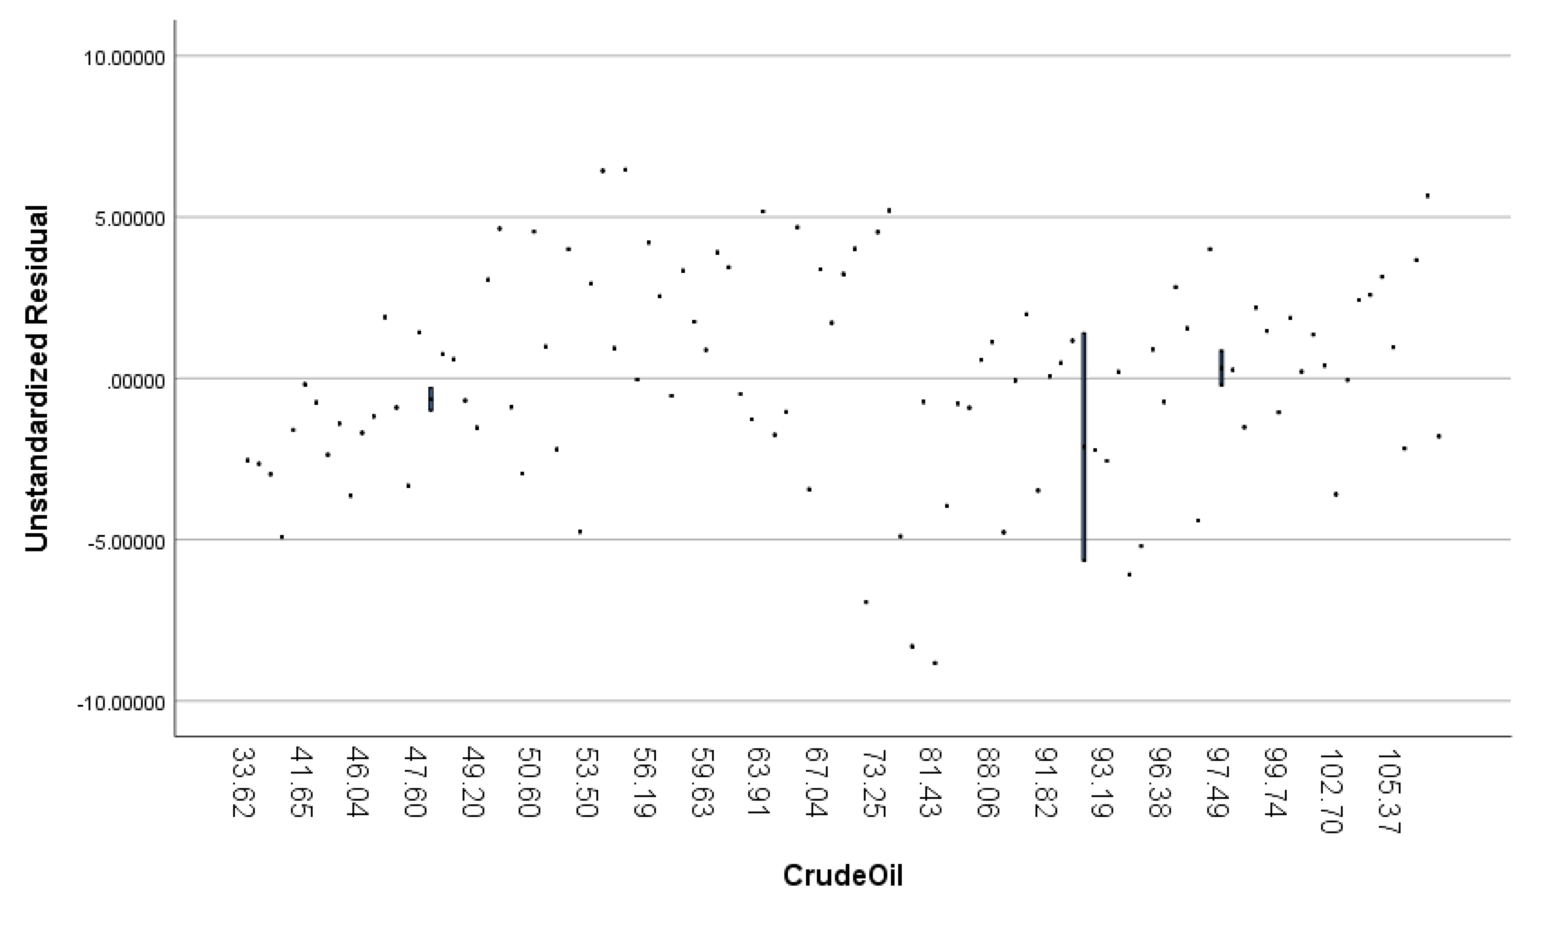

Figure 4 A scatterplot of residuals against crude oil X2

3) Test of an equal variance assumption

The following scatterplot of residual against the predicted value, Figure 5, is checking the equal variance assumption. There is no pattern on the scatterplot and the equal variance assumption is not violated.

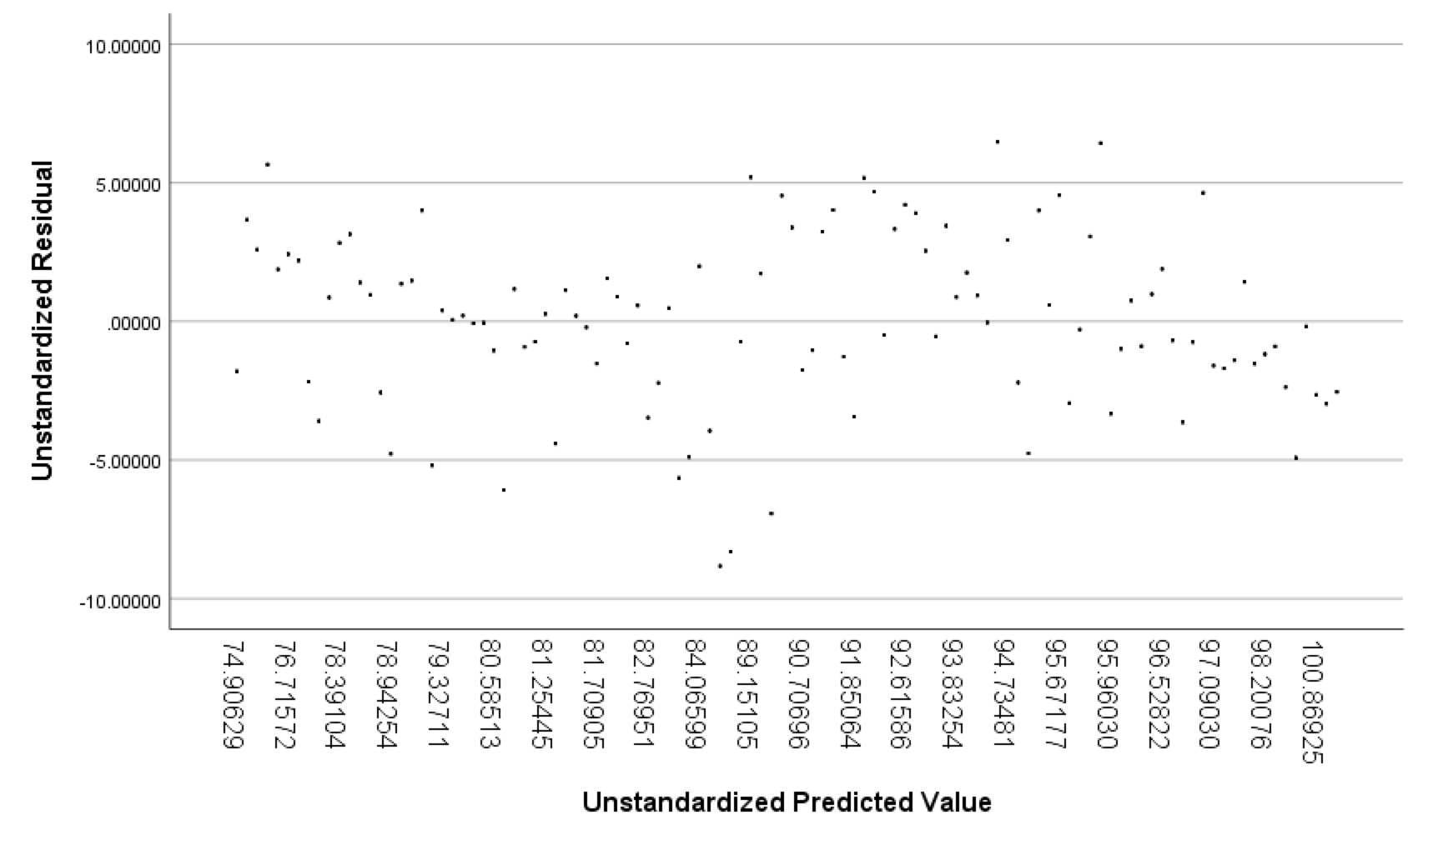

Figure 5 A scatterplot of residual against predicted value Y

4) Test of normality assumption

The history of standardized residuals, Figure 6, shows that it is normally distributed. All the points in a normal profitability line is distributed along the line. The normality assumption is not violated.

Since all 4 assumptions have not violated, we conduct the multiple linear regression analysis. The table generated from SPSS in Figure 8, 9 and 10. The number of independent variable, k, is 2 and the sample size, n, is 107. The standard error of estimate is 3.176.

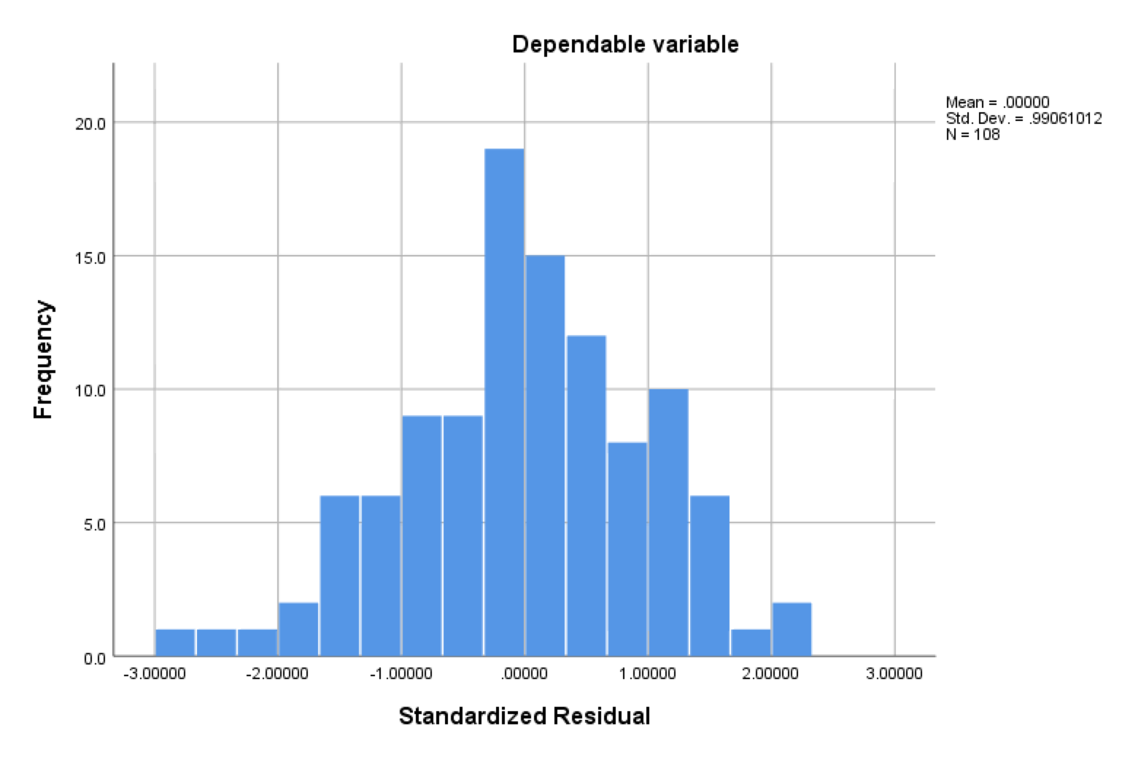

Figure 6 Histogram of standardized residuals

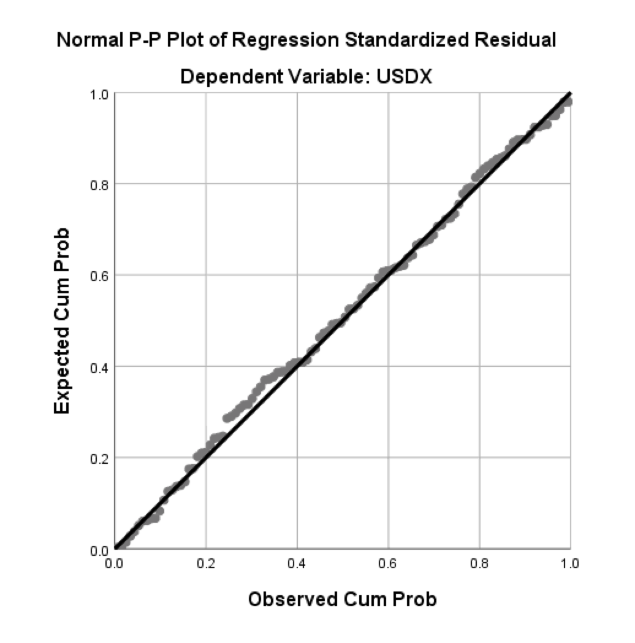

Figure 7 A normal probability plot of standardized residuals

Multiple Linear regression using SPSS

Multiple regression model is constructed of the coefficient table, Figure 10. There are inverse relationships between USDX against gold and oil prices.

Yi = β0+ β1 X1i + β2 X2i + εi

Y = 124.403 -0.01X1 -0.282X2

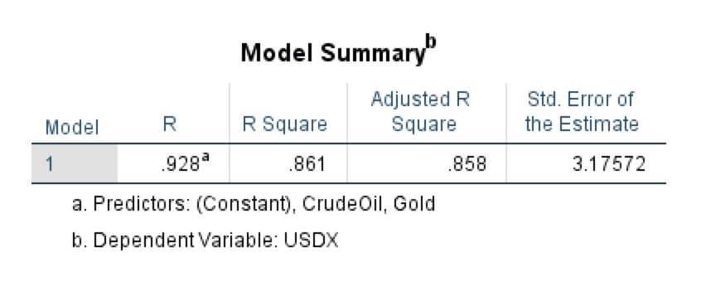

Figure 8. A summary from the SPSS result

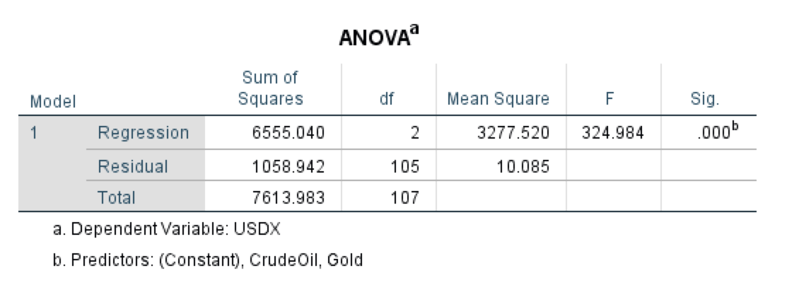

Figure 9 ANOVA table from the SPSS result

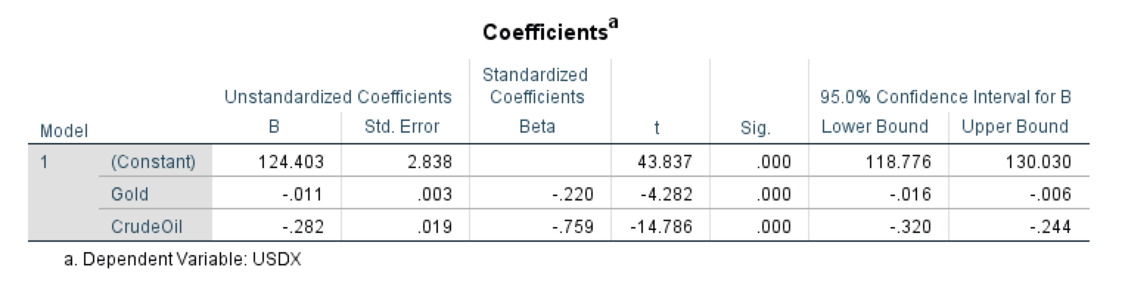

Figure 10 Coefficient table from the SPSS result

At the 5% significant level, we like to see the significant relationship between USDX against gold and crude oil prices. Hypothesis test is conducted in the following 5 steps.

Step 1: Hypothesis

H0: β1 = β2 =0 (there is no relation between USDX and combined Gold and Oil price)

H1: at least one βi is not equal to zero (there is relation between USDX and combined Gold and Oil price)

Step 2: Significant level α = 0.05

Step 3: F Stat = 324.984 from Figure 9

Step 4: Critical value of F = 3.354 (using Casio calculator)

Step 5: Decision

Reject H0 because the value of Fstat is in the rejection region. There is a relation between USDX and combined gold and oil price.

Inference Statistics Analysis (t-test)

We like to find a linear relationship between USDX and Gold while Crude oil price constant and a linear relationship between USDX and gold price holding oil price constant. T-test is conducted.

* Linear relation between USDX and Gold while Crude oil price constant

Step 1: Hypothesis

H0: β1 =0 (there is no relation between USDX and gold price holding oil price constant)

H1: β1 ≠0 (there is relation between USDX and gold price holding oil price constant)

Step 2: Significant α = 0.05

Step 3: Test statistic t = -4.282 from Figure 10.

Step 4: Critical value for t is ±2.0518

Step 5: Decision

Reject H0 because the test statistic is in the rejection region. There is a relation between USDX and gold price holding oil price constant

* Linear relation between USDX and Crude oil while gold price constant

Step 1: Hypothesis

H0: β1 =0 (there is no relation between USDX and oil price holding gold price constant)

H1: β1 ≠0 (there is relation between USDX and oil price holding gold price constant)

Step 2: Significant α = 0.05 from Figure 10

Step 3: Test statistic t = -4.282

Step 4: Critical value for t is ±2.0518

Step 5:Decision

Reject H0 because test statistic is in the rejection region. There is a relation between USDX and gold price holding oil price constant

**Conclusion and Interpretation**

The 4 assumption tests are conducted before we use a multiple linear regression model and all assumptions are not violated. We conclude that the US dollar index, USDX, has an inverse relationship with oil and gold price within 95% confidence level. The coefficient of determination is 0.86 in Figure 8 and it means 86% of US dollar index price is explained by gold and crude oil prices. We have a confidence interval value with 95% confidence in Figure 10. As each dollar increases in gold price, the interval of USDX will decrease by $0.016 to $0.006. And as each dollar increases in oil prices, the interval of USDX will decrease by $0.320 to $0.224.

We conclude that US dollars and commodity prices are highly related. The analysis shows that as the US dollar price changes, other commodity’s prices such as gold and crude oil have a reverse effect. These patterns are described in economics theory and this is one way of proving the relationship between the US dollar and commodities. Using the multiple linear regression model, these patterns are proved under the assumptions within the significance level.

Appendix A. Data Set

|  |  |  |  |  |  |  |  |
| --- | --- | --- | --- | --- | --- | --- | --- |
| Date | USDX | Gold | Crude oil | Date | USDX | Gold | Crude oil |
| Aug-10 | $ 83.25 | $ 1,248.30 | $ 71.92 | Apr-12 | $ 78.85 | $ 1,663.40 | $ 104.87 |
| Sep-10 | $ 78.94 | $ 1,307.80 | $ 79.97 | May-12 | $ 83.13 | $ 1,562.60 | $ 86.53 |
| Oct-10 | $ 77.46 | $ 1,357.10 | $ 81.43 | Jun-12 | $ 81.75 | $ 1,603.50 | $ 84.96 |
| Nov-10 | $ 81.27 | $ 1,385.00 | $ 84.11 | Jul-12 | $ 82.71 | $ 1,610.50 | $ 88.06 |
| Dec-10 | $ 79.29 | $ 1,421.10 | $ 91.38 | Aug-12 | $ 81.22 | $ 1,684.60 | $ 96.47 |
| Jan-11 | $ 77.87 | $ 1,333.80 | $ 92.19 | Sep-12 | $ 80.03 | $ 1,771.10 | $ 92.19 |
| Feb-11 | $ 76.92 | $ 1,409.30 | $ 96.97 | Oct-12 | $ 79.99 | $ 1,717.50 | $ 86.24 |
| Mar-11 | $ 76.07 | $ 1,438.90 | $ 106.72 | Nov-12 | $ 80.16 | $ 1,710.90 | $ 88.91 |
| Apr-11 | $ 73.11 | $ 1,556.00 | $ 113.93 | Dec-12 | $ 79.87 | $ 1,674.80 | $ 91.82 |
| May-11 | $ 74.70 | $ 1,535.90 | $ 102.70 | Jan-13 | $ 79.23 | $ 1,660.60 | $ 97.49 |
| Jun-11 | $ 74.64 | $ 1,502.30 | $ 95.42 | Feb-13 | $ 82.00 | $ 1,577.70 | $ 92.05 |
| Jul-11 | $ 74.04 | $ 1,628.30 | $ 95.70 | Mar-13 | $ 83.18 | $ 1,594.80 | $ 97.23 |
| Aug-11 | $ 74.17 | $ 1,828.50 | $ 88.81 | Apr-13 | $ 81.81 | $ 1,472.20 | $ 93.46 |
| Sep-11 | $ 79.08 | $ 1,620.40 | $ 79.20 | May-13 | $ 83.40 | $ 1,392.60 | $ 91.97 |
| Oct-11 | $ 76.31 | $ 1,724.20 | $ 93.19 | Jun-13 | $ 83.38 | $ 1,374.90 | $ 96.56 |
| Nov-11 | $ 78.49 | $ 1,745.50 | $ 100.36 | Jul-13 | $ 81.54 | $ 1,468.60 | $ 105.03 |
| Dec-11 | $ 80.52 | $ 1,565.80 | $ 98.83 | Aug-13 | $ 82.14 | $ 1,573.00 | $ 107.65 |
| Jan-12 | $ 79.42 | $ 1,737.80 | $ 98.48 | Sep-13 | $ 80.32 | $ 1,485.40 | $ 102.33 |
| Feb-12 | $ 78.79 | $ 1,709.90 | $ 107.07 | Oct-13 | $ 80.26 | $ 1,453.90 | $ 96.38 |
| Mar-12 | $ 79.14 | $ 1,669.30 | $ 103.02 | Nov-13 | $ 80.66 | $ 1,377.20 | $ 92.72 |

|  |  |  |  |  |  |  |  |
| --- | --- | --- | --- | --- | --- | --- | --- |
| Date | USDX | Gold | Crude oil | Date | USDX | Gold | Crude oil |
| Dec-13 | $ 80.19 | $ 1,338.40 | $ 98.42 | Jul-15 | $ 97.44 | $ 1,143.50 | $ 47.12 |
| Jan-14 | $ 81.40 | $ 1,370.20 | $ 97.49 | Aug-15 | $ 95.85 | $ 1,177.50 | $ 49.20 |
| Feb-14 | $ 79.72 | $ 1,446.40 | $ 102.59 | Sep-15 | $ 96.48 | $ 1,149.40 | $ 45.09 |
| Mar-14 | $ 80.25 | $ 1,407.70 | $ 101.58 | Oct-15 | $ 97.02 | $ 1,169.90 | $ 46.59 |
| Apr-14 | $ 79.53 | $ 1,405.70 | $ 99.74 | Nov-15 | $ 100.21 | $ 1,098.30 | $ 41.65 |
| May-14 | $ 80.40 | $ 1,342.80 | $ 102.71 | Dec-15 | $ 98.75 | $ 1,095.80 | $ 37.04 |
| Jun-14 | $ 79.81 | $ 1,419.00 | $ 105.37 | Jan-16 | $ 99.65 | $ 1,140.00 | $ 33.62 |
| Jul-14 | $ 81.52 | $ 1,385.40 | $ 98.17 | Feb-16 | $ 98.22 | $ 1,255.00 | $ 33.75 |
| Aug-14 | $ 82.78 | $ 1,384.50 | $ 95.96 | Mar-16 | $ 94.58 | $ 1,261.60 | $ 38.34 |
| Sep-14 | $ 86.05 | $ 1,310.60 | $ 91.16 | Apr-16 | $ 93.05 | $ 1,321.90 | $ 45.92 |
| Oct-14 | $ 87.02 | $ 1,248.50 | $ 80.54 | May-16 | $ 95.88 | $ 1,252.70 | $ 49.10 |
| Nov-14 | $ 88.41 | $ 1,244.80 | $ 66.15 | Jun-16 | $ 96.20 | $ 1,358.00 | $ 48.33 |
| Dec-14 | $ 90.65 | $ 1,251.30 | $ 53.27 | Jul-16 | $ 95.49 | $ 1,395.20 | $ 41.60 |
| Jan-15 | $ 95.00 | $ 1,325.40 | $ 48.24 | Aug-16 | $ 96.01 | $ 1,347.00 | $ 44.70 |
| Feb-15 | $ 95.32 | $ 1,267.60 | $ 49.76 | Sep-16 | $ 95.39 | $ 1,353.50 | $ 48.24 |
| Mar-15 | $ 98.66 | $ 1,230.80 | $ 47.60 | Oct-16 | $ 98.42 | $ 1,312.80 | $ 46.86 |
| Apr-15 | $ 94.71 | $ 1,231.90 | $ 59.63 | Nov-16 | $ 101.54 | $ 1,214.10 | $ 49.44 |
| May-15 | $ 96.99 | $ 1,240.80 | $ 60.30 | Dec-16 | $ 102.29 | $ 1,199.50 | $ 53.72 |
| Jun-15 | $ 95.66 | $ 1,229.70 | $ 59.47 | Jan-17 | $ 99.48 | $ 1,257.00 | $ 52.81 |

|  |  |  |  |  |  |  |  |
| --- | --- | --- | --- | --- | --- | --- | --- |
| Date | USDX | Gold | Crude oil | Date | USDX | Gold | Crude oil |
| Feb-17 | $ 101.13 | $ 1,299.70 | $ 54.01 | Sep-18 | $ 94.74 | $ 1,213.20 | $ 73.25 |
| Mar-17 | $ 100.22 | $ 1,295.10 | $ 50.60 | Oct-18 | $ 96.90 | $ 1,233.00 | $ 65.31 |
| Apr-17 | $ 98.90 | $ 1,312.00 | $ 49.33 | Nov-18 | $ 97.20 | $ 1,237.90 | $ 50.93 |
| May-17 | $ 96.85 | $ 1,314.40 | $ 48.32 | Dec-18 | $ 95.74 | $ 1,294.20 | $ 45.41 |
| Jun-17 | $ 95.42 | $ 1,281.20 | $ 46.04 | Jan-19 | $ 95.30 | $ 1,331.60 | $ 53.79 |
| Jul-17 | $ 92.72 | $ 1,305.80 | $ 50.17 | Feb-19 | $ 96.04 | $ 1,322.70 | $ 57.22 |
| Aug-17 | $ 92.63 | $ 1,354.30 | $ 47.23 | Mar-19 | $ 96.85 | $ 1,298.50 | $ 60.14 |
| Sep-17 | $ 92.88 | $ 1,320.90 | $ 51.67 | Apr-19 | $ 97.20 | $ 1,285.70 | $ 63.91 |
| Oct-17 | $ 94.43 | $ 1,307.50 | $ 54.38 | May-19 | $ 97.67 | $ 1,305.80 | $ 53.50 |
| Nov-17 | $ 93.00 | $ 1,314.00 | $ 57.40 | Jun-19 | $ 95.67 | $ 1,395.15 | $ 58.47 |
| Dec-17 | $ 91.83 | $ 1,347.40 | $ 60.42 | Jul-19 | $ 96.82 | $ 1,427.60 | $ 56.19 |
| Jan-18 | $ 88.95 | $ 1,383.00 | $ 64.73 |  |  |  |  |
| Feb-18 | $ 90.55 | $ 1,361.00 | $ 61.64 |  |  |  |  |
| Mar-18 | $ 89.81 | $ 1,364.90 | $ 64.94 |  |  |  |  |
| Apr-18 | $ 91.63 | $ 1,357.60 | $ 68.57 |  |  |  |  |
| May-18 | $ 93.96 | $ 1,336.30 | $ 67.04 |  |  |  |  |
| Jun-18 | $ 94.35 | $ 1,284.60 | $ 74.15 |  |  |  |  |
| Jul-18 | $ 94.28 | $ 1,250.90 | $ 68.76 |  |  |  |  |
| Aug-18 | $ 95.08 | $ 1,223.40 | $ 69.80 |  |  |  |  |

**Bibliography**

“Crude oil Futures Historical Prices.” *Investing.com Canada*,*Investing.com Canada*, Investing.com, [ca.investing.com/commodities/crude-oil-historical-data](https://ca.investing.com/commodities/crude-oil-historical-data).

“Gold Futures Historical Prices.” *Investing.com Canada*,*Investing.com Canada*, Investing.com, ca.investing.com/commodities/gold-historical-data.

“US Dollar Index Historical Data: USD Index Historical Data.” *Investing.com Canada*, Investing.com, ca.investing.com/currencies/us-dollar-index-historical-data.

Kowalski. “Impact of the Dollar on Commodity Prices.” *The Balance*, The Balance, 7 July 2019, [www.thebalance.com/how-the-dollar-impacts-commodity-prices-809294](http://www.thebalance.com/how-the-dollar-impacts-commodity-prices-809294).

“Why Trade Futures Instead of ETFs? - CME Group.” *Futures & Options Trading for Risk Management - CME Group*, 2019, [www.cmegroup.com/education/courses/futures-vs-etfs/why-trade-futures-instead-of-etfs.html](http://www.cmegroup.com/education/courses/futures-vs-etfs/why-trade-futures-instead-of-etfs.html).